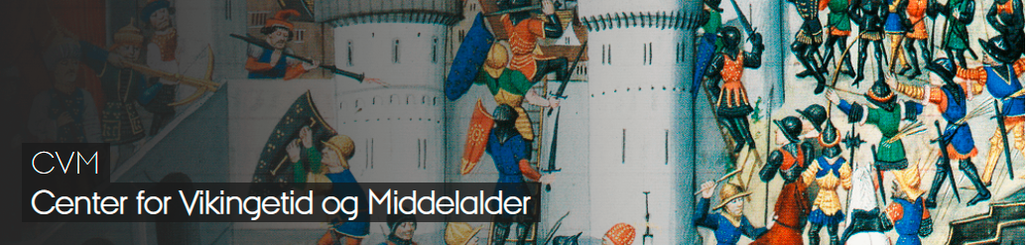
Arabic Erotic Manuscript Traditions and Attitudes to Sexuality in the Medieval Islamic World

Pernilla Myrne
Senior Lecturer,
Department of Languages & Literatures,
University of Gothenburg

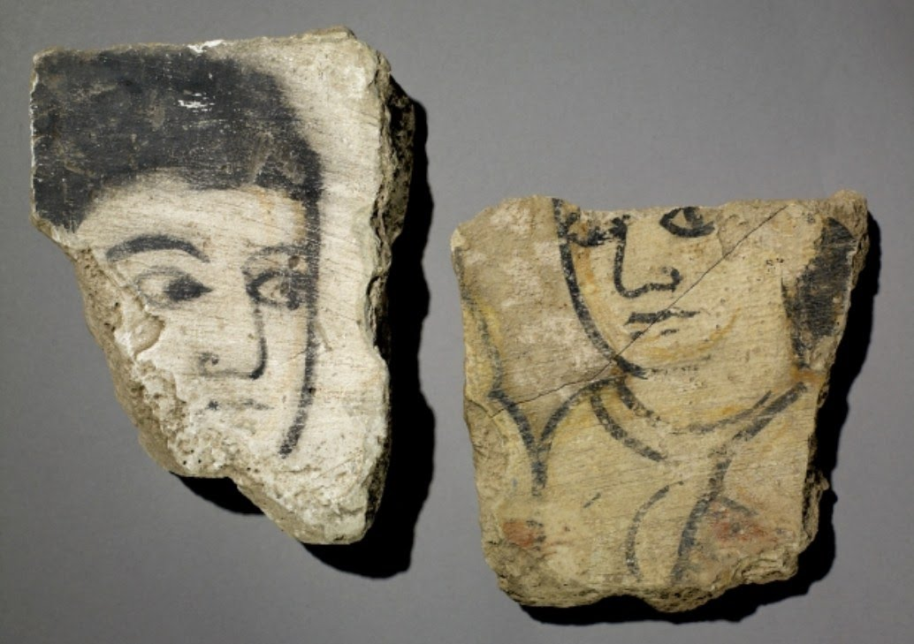

Brudstykker af et vægmaleri, muligvis figurer fra et ḥarīm. Fundet i Kalifens palads (Dar al-Khalifa) i Samarra, Irak. (Abbasid Kalifatet, 800 tallet).

Place: Aarhus University, Jens Chr. Skous Vej 5,
Building 1461, room 516, 8000 Aarhus C.
Date: 9th December 2021
Time: 2.15 pm – 5 pm
Registration: Not required

After the seminar there will be served refreshments.
Contact: Adjunkt Richard Cole (richardcole@cas.au.dk), Department of History, University of Aarhus

