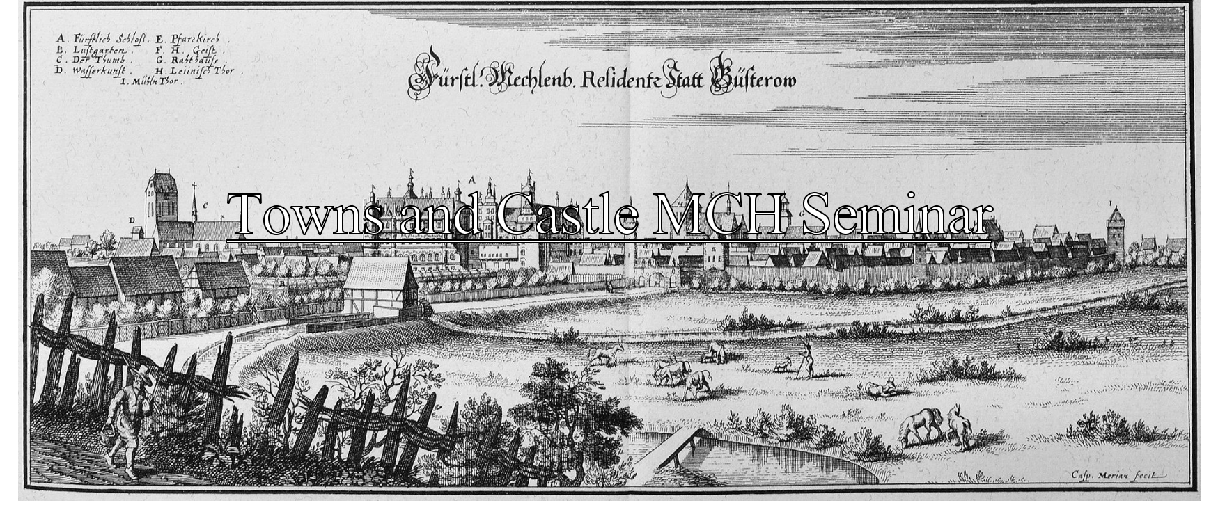

Friday, 25/11-22

Materials, Culture & Heritage, public Seminar "Towns and Castles"
(Foredragssalen/Lecture Hall 4206-139)

13:00-13:05 Rainer Atzbach, Aarhus: Introduction
1st block: The Western Baltic: Schleswig and Holstein
13:10-13:30 Bjørn Poulsen, Aarhus: Schwabsted and Søborg – Council and Economy in Small Towns
13:30-13:50 Stefan Magnussen, Kiel: The Town After the Lord Left His Castle
13:50-14:10: Frederic Zangel, Kiel: The Castles in Lübeck and Their Image in the Written Sources
14:10-14:30: Questions & Answers
14:30-14:45: Coffee Break
2nd block: The Southern and Eastern Baltic
14:45-15:05:Fred Ruchhöft, Goldberg: Castle and Town in Mecklenburg
15:05-15:25: Luisa Radohs, Freiburg i.Br.: Stralsund's Medieval Townscape int the Light of Lordly-Communal
15:25-15:35: Questions & Answers
15:35-15:55: Villu Kadaukas, Talinn, Castle and Town in Estonia
16:00 Martin Ebert: Towns and Castles – Some Thoughts and Final discussion
19:00 Speaker's dinner at Unico-Restaurant, Ny Moesgårdvej 50, 8270 Højbjerg

